**DAILY ONLINE ACTIVITIES SUMMARY**

|  |  |  |  |  |  |  |  |  |
| --- | --- | --- | --- | --- | --- | --- | --- | --- |
| **Date:** | 04-06-2020 | | | | | **Name:** | K S Prajwal | |
| **Sem & Sec** | Vi A sec | | | | | **USN:** | 4AL18CS032 | |
| **Online Test Summary** | | | | | | | | |
| **Subject** | | Micro controller and embedded system | | | | | | |
| **Max. Marks** | | 20 | | **Score** | | | 16 | |
| **Certification Course Summary** | | | | | | | | |
| **Course** | **Python and Django Full Stack Web Developer Bootcamp** | | | | | | | |
| **Certificate Provider** | | | Udemy | | **Duration** | | | **3 hr** |
| **Coding Challenges** | | | | | | | | |
| **Problem Statement:**  1: write a java program to read three integer values from the keyboard and find the sum of the values. Declare a variable "sum" of type int and store  the result in it.  2: Write a C++ program to find the missing number in array | | | | | | | | |
| **Status:** completed | | | | | | | | |
| **Uploaded the report in Github** | | | | | yes | | | |
| **If yes Repository name** | | | | | <https://github.com/alvas-education-foundation/KS_Prajwal> | | | |
| **Uploaded the report in slack** | | | | | yes | | | |

Online Test Details: (Attach the snapshot and briefly write the report for the same)

Certification Course Details: (Attach the snapshot and briefly write the report for the same)

Coding Challenges Details: (Attach the snapshot and briefly write the report for the same)

**Online Test Details:**

MES test was scheduled from 02:00pm to 2:30pm. The portion for the IA was 3rd module there were 20 questions and the time assigned was 30minutes the questions were MCQ type. I scored 16/20.

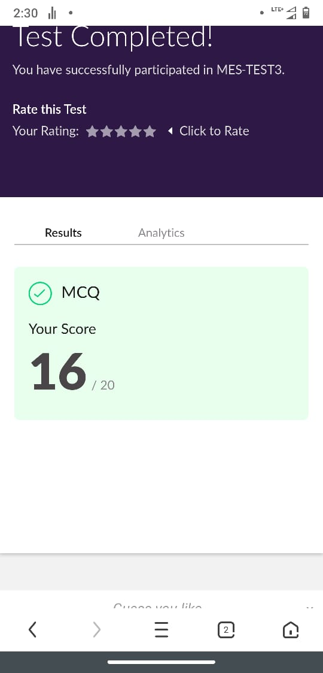

Snapshot of certification course:

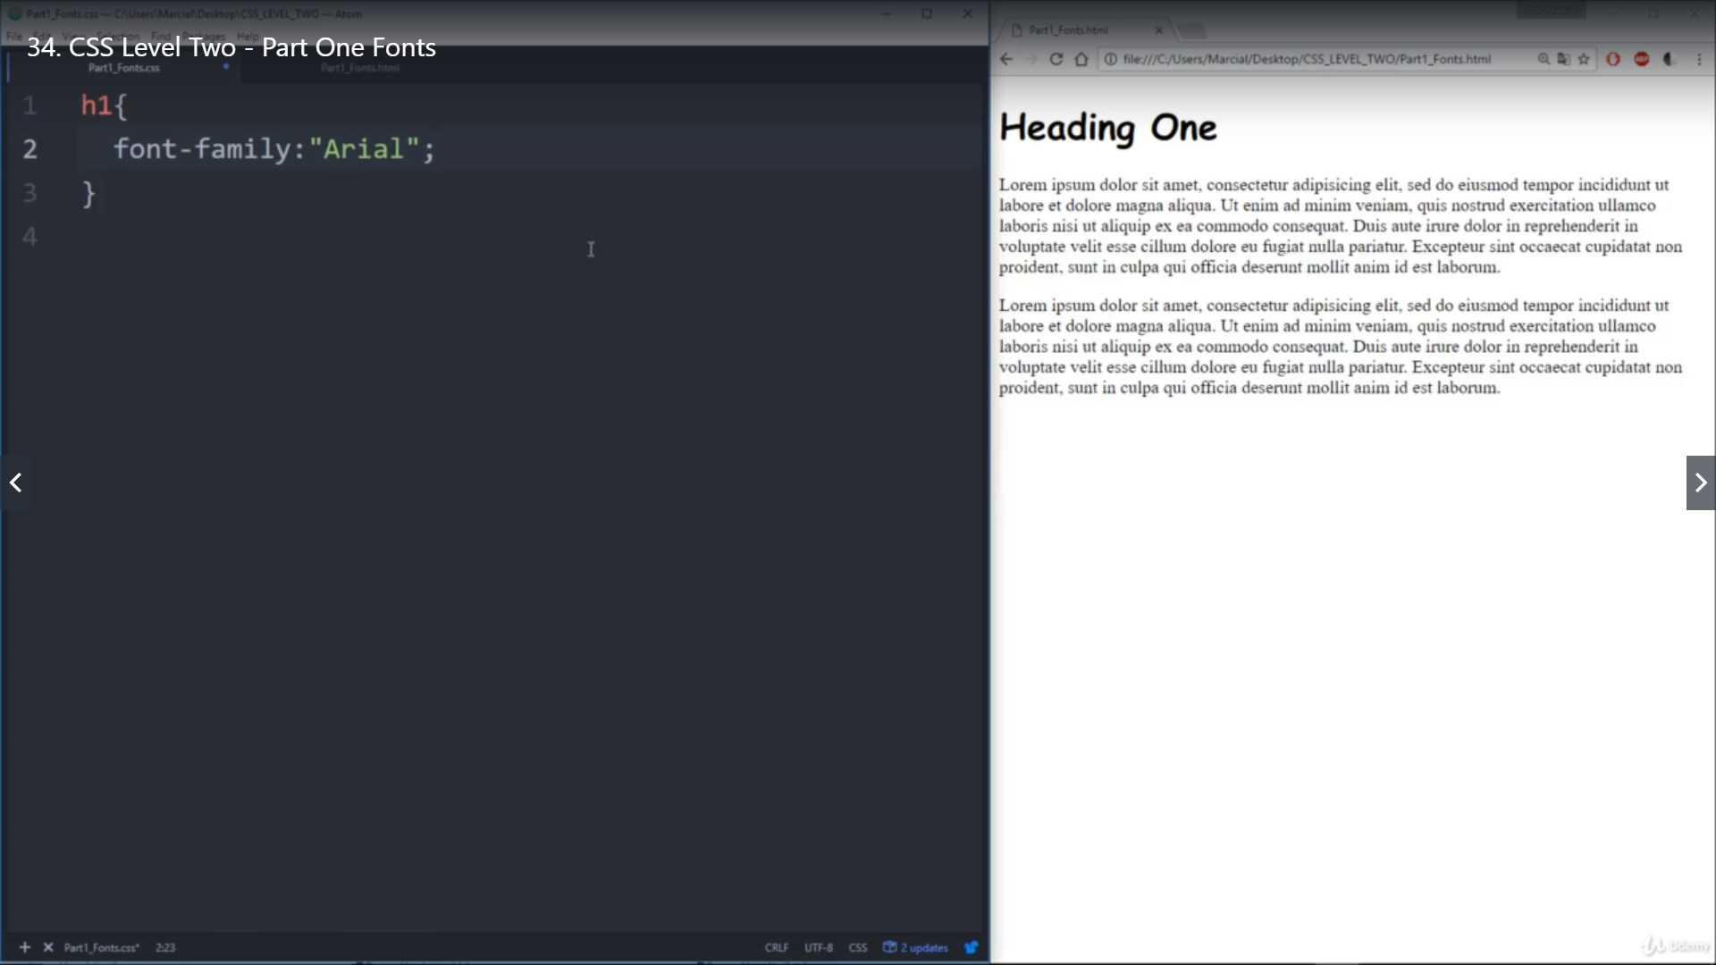

This section was about the advance properties of CSS it was about how use different fonts download it from external source and apply it. It also explained the boxing concept.

**Online coding:**

Problem 1: (using Java) write a java program to read three integer values from the keyboard and find the sum of the values. Declare a variable "sum" of type int and store the result in it.

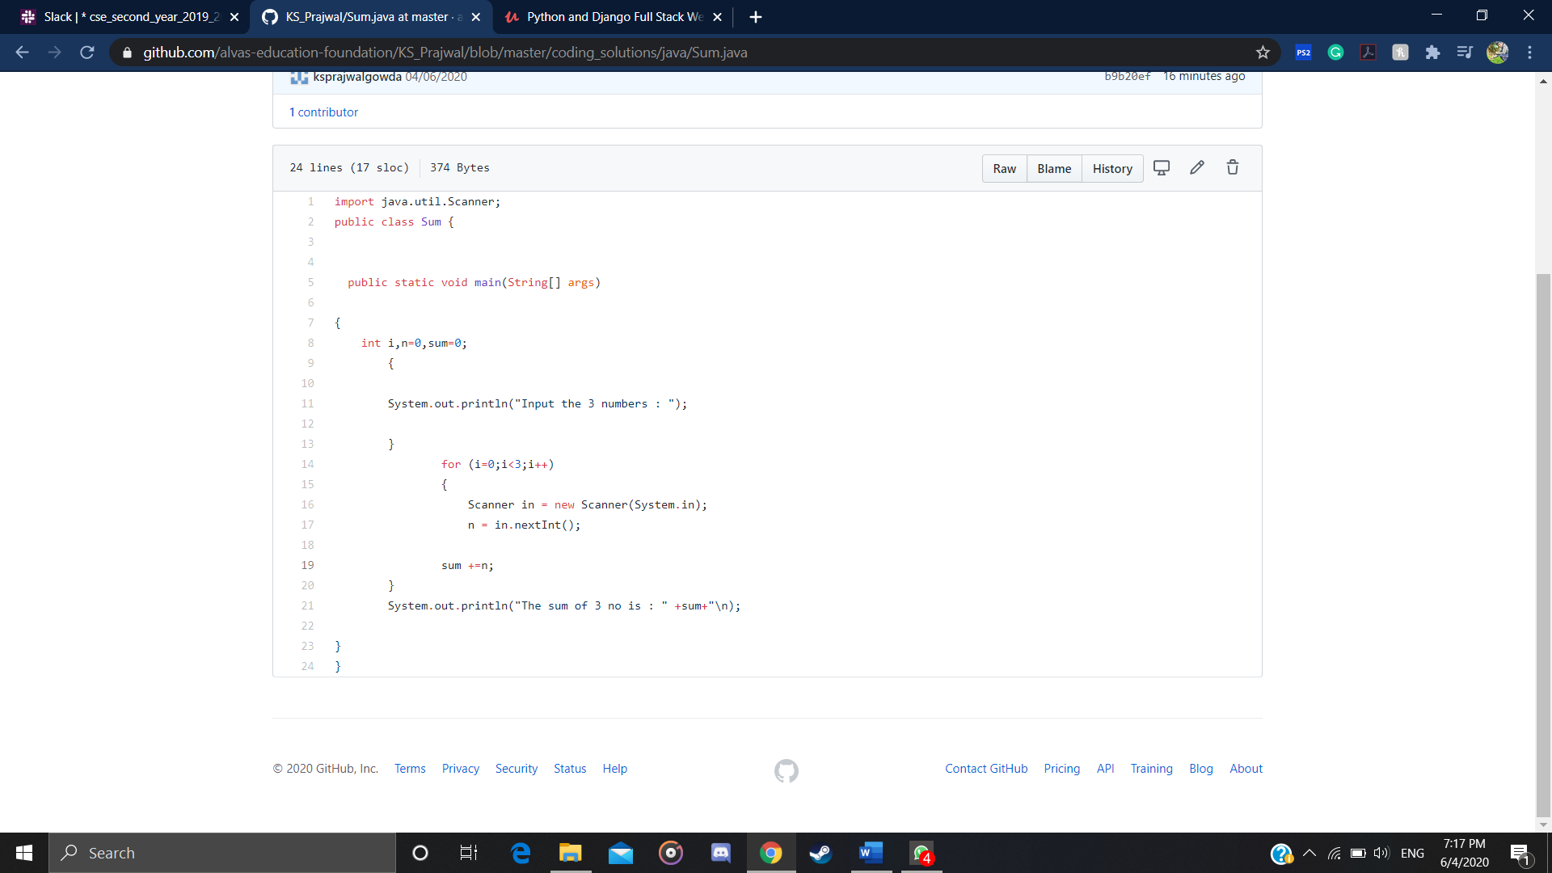

Problem 2: (using C++) Write a C++ program to find the missing number in array

